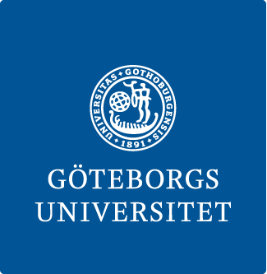
Bachelor’s program KULTUR
Department of Cultural Sciences, University of Gothenburg

CERTIFICATION OF INTERNSHIP

Workplace: _________________________________________________

Trainee: ____________________________________________________

Civic registration number: _____________________________________

Time period for internship: from weak 40 until weak 47 2024

At the beginning of the internship, an internship plan was drawn up between the internship host and the trainee, outlining the orientation and implementation of the internship.
It is hereby confirmed that the internship was carried out during the specified time period and in accordance with the internship plan with regard to its content, scope and design.

Place and date: _________________________________________

_____________________________________________________
Signature of the internship host

_____________________________________________________
Clarification of signature

The student leaves this certificate to the course leader in connection with the final examination seminars at the University of Gothenburg.

