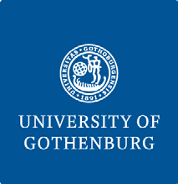
The University of Gothenburg’s Sustainability Thesis Award-GUSTA

Supervisors’ Assessment Form
Dear Supervisor,
The advisee, with the details below, is applying for a sustainability thesis award project at the University of Gothenburg. As your view plays an integral role for the selection process, we would appreciate if you would kindly take a few minutes and write, in the space below, a short assessment of the work in light of its contribution to sustainable development. What important sustainability message the thesis contributes? (Max. 3000 characters)
Student’s Name:
Institution’s Name:
Thesis Title:
Study Program:
Type your assessment below:

Your name and Signature:
This form must be submitted before August 31, 2024 along with oter documents.

